Pre-UAS Quiz: Database Fundamental
Oracle SQL - GlobalTech HR Information System
Student Name: ________________________________
Student ID: _________________________________
Class: ______________________________________
Date: ____________________________

Case Study: GlobalTech Human Resource Information System (GHRIS)
GlobalTech is a multinational technology company with offices in multiple countries and regions. The company manages employees working in departments such as Administration, IT, Sales, Finance, Human Resources, and Marketing.
Each employee is assigned to a specific job role and department. Departments are located in various cities worldwide, and each location belongs to a country, which is part of a larger geographic region. Some employees report directly to managers, while others manage teams across multiple departments.
To support career development, GlobalTech records employee job transfers and promotions in the JOB_HISTORY table. Human Resources regularly analyzes employee performance, salary distribution, department growth, and workforce allocation across regions.
The HR department also faces several challenges. Employee names are entered inconsistently, duplicate job titles sometimes appear in reports, some employees have changed jobs multiple times, and management wants reusable reports for salary, department, region, and job history analysis. New job positions must be generated automatically, employee email addresses must follow company standards, and executives frequently request analytical reports involving multiple related tables.
As a database analyst, you are required to create Oracle SQL queries to support these business needs using the GlobalTech HR database schema.

Instructions
- Answer all questions using Oracle SQL syntax.
- Use the ERD tables: EMPLOYEES, JOBS, JOB_HISTORY, DEPARTMENTS, LOCATIONS, COUNTRIES, REGIONS, and JOB_GRADES.
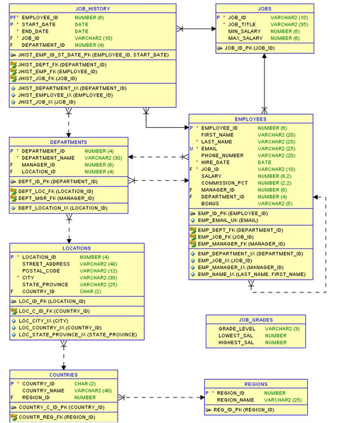

Quiz Questions

Question 1 - Single Row Functions
GlobalTech wants employee names displayed consistently. Write a query to display employee_id, employee full name in uppercase, email in lowercase, and the first three characters of the last name. Use UPPER, LOWER, and SUBSTR.

Question 2 - Single Row Functions + CASE
The HR department wants to classify salaries. Display employee_id, last_name, salary, and salary_category. Salary category rules: salary >= 15000 = HIGH; salary >= 8000 = MEDIUM; otherwise = LOW. Use CASE.

Question 3 - JOIN + Single Row Functions
Display employee full name, job_title, and department_name. Format the employee name using INITCAP. Use EMPLOYEES, JOBS, and DEPARTMENTS.

Question 4 - OUTER JOIN
Management wants to identify departments that currently have no employees assigned. Display department_id, department_name, and employee_id. Ensure all departments appear in the result.

Question 5 - SELF JOIN
Display employee name, manager name, employee job_id, and manager job_id. Ensure employees without managers still appear in the report.

Question 6 - Group Functions
Display department_id, total employees, average salary, and highest salary. Use COUNT, AVG, and MAX.

Question 7 - Group Functions + HAVING
Display departments whose average salary exceeds 10000. Show department_id and average salary.

Question 8 - Subquery (Single Value)
Display employees whose salary is above the company average salary.

Question 9 - Subquery (Single Value)
Display employees who earn more than employee 'King'.

Question 10 - Subquery (List of Values)
Display employees working in departments located in the United States. Use IN and subquery. Tables involved: EMPLOYEES, DEPARTMENTS, and LOCATIONS.

Question 11 - Correlated Subquery
Display employees whose salary is greater than the average salary of their own department.

Question 12 - JOIN + Group Function + Subquery
Display department_name and total employees. Only show departments with employee counts above the overall average employee count per department.

Question 13 - Regular Expression
The company requires employee emails to follow a valid email format. Display all employees whose email follows a valid email pattern. Use REGEXP_LIKE.

Question 14 - Sequence + Synonym
GlobalTech plans to create new job positions. a) Create a sequence named SEQ_JOB. b) Show an INSERT statement using SEQ_JOB.NEXTVAL. c) Create a synonym JOB_LIST for JOBS. d) Display all records from JOB_LIST.

Question 15 - View + Multiple Concepts
Management frequently requests a report showing employee salary information. Create a view named VW_EMPLOYEE_SALARY_REPORT containing employee_id, employee_name, department_name, job_title, and salary. Then write a query displaying only employees whose salary is above the company average salary.

